**Docker Task**

**Task Description:**

Install docker on EC2 and explore the docker commands (docker images, containers, volumes, network).

Explanation:

1. Sign in to AWS Console

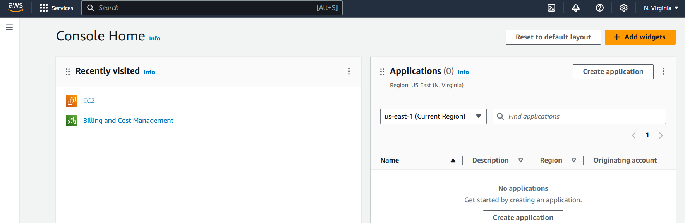

1. Launch an EC2 instance

Navigate to the EC2 Dashboard

Click on Launch Instance.

Choose an Amazon Machine Image (AMI)- Ubuntu-based image

Choose an Instance Type - t2.micro

Review and Launch the instance.

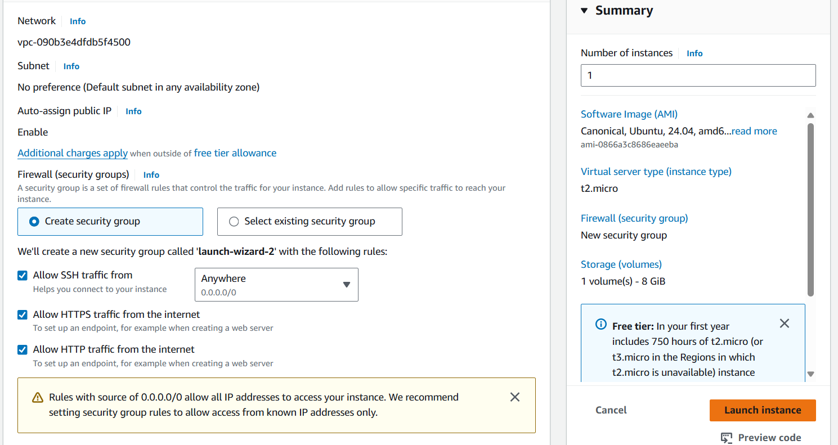

1. Connect to EC2 Instance

Once the instance is running, click View Instances.

Select the instance,click on Connect.

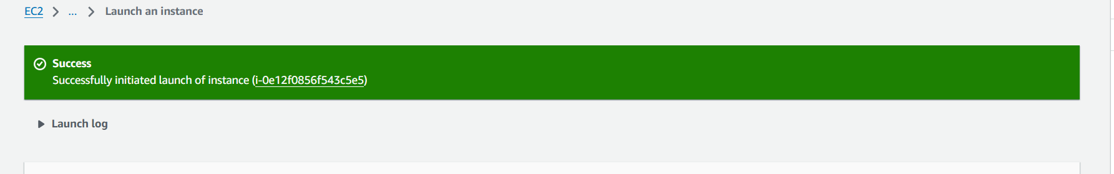

1. Use the SSH client tab instructions to connect to the instance using a terminal

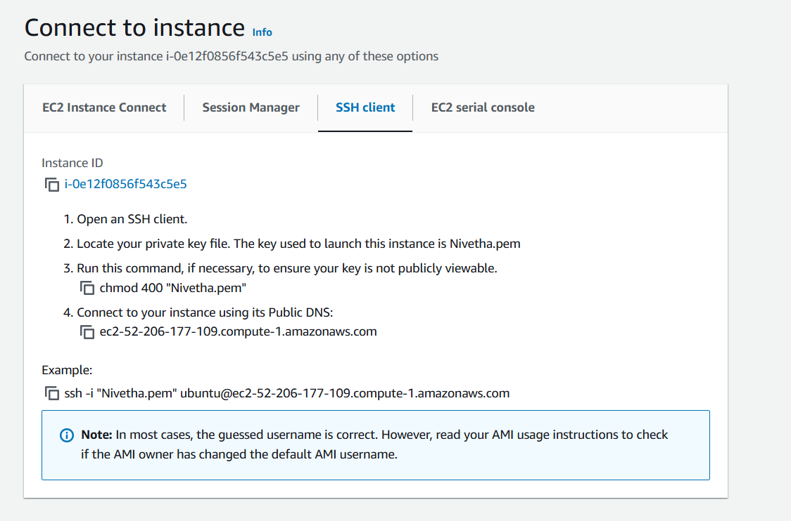

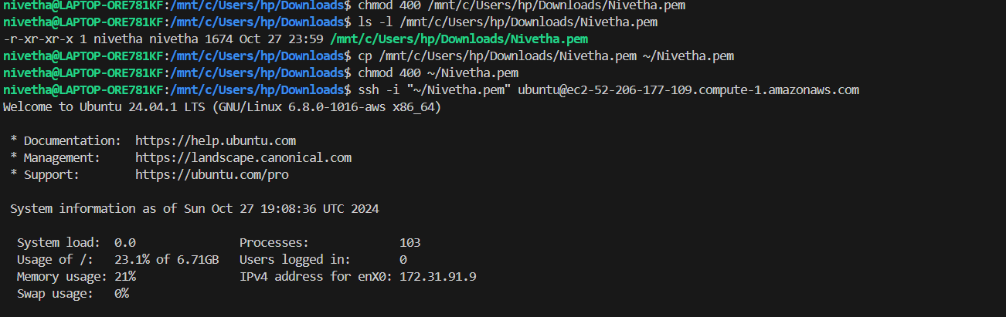

1. Install Docker

Update package - sudo apt-get update

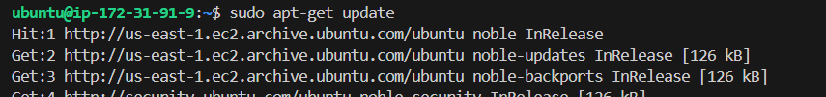

Install Docker- sudo apt-get install docker.io

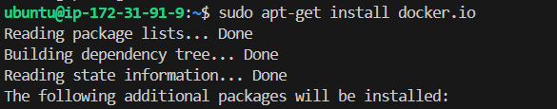

Start and Enable - sudo systemctl start docker

sudo systemctl enable docker

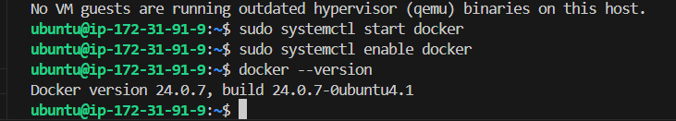

1. Docker Commands
2. Docker Images

View all Docker images on your system – sudo docker images



Pull a Docker Image from Docker Hub - sudo docker pull hello-world

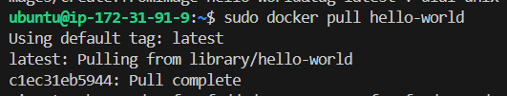

Run an Image -sudo docker run hello-world

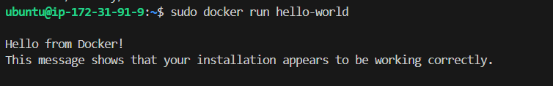

1. Docker Containers

View running containers – sudo docker ps



View all containers – sudo docker ps -a



Run a container – sudo docker run -it ubuntu bash

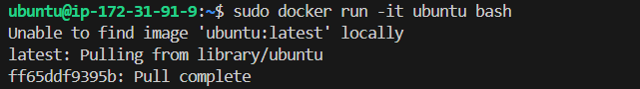

Exit the Container – exit



Stop the Container – sudo docker stop 2748a588731d



Verify if the Container is Stopped- sudo docker ps -a



1. Docker Volumes

Create volume – sudo docker volume create myvolume

View all volumes – sudo docker volume ls

Run a container with a volume – sudo docker run -it -v myvolume:/mydata ubuntu bash

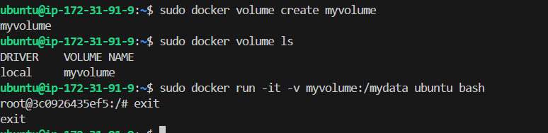

1. Docker Network

View all Docker networks - sudo docker network ls

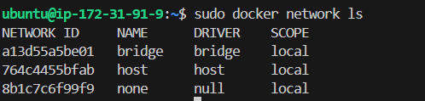

Create a new network - sudo docker network create mynetwork



Run a container in a specific network - sudo docker run -it --network=mynetwork ubuntu bash

